Public Affairs Office
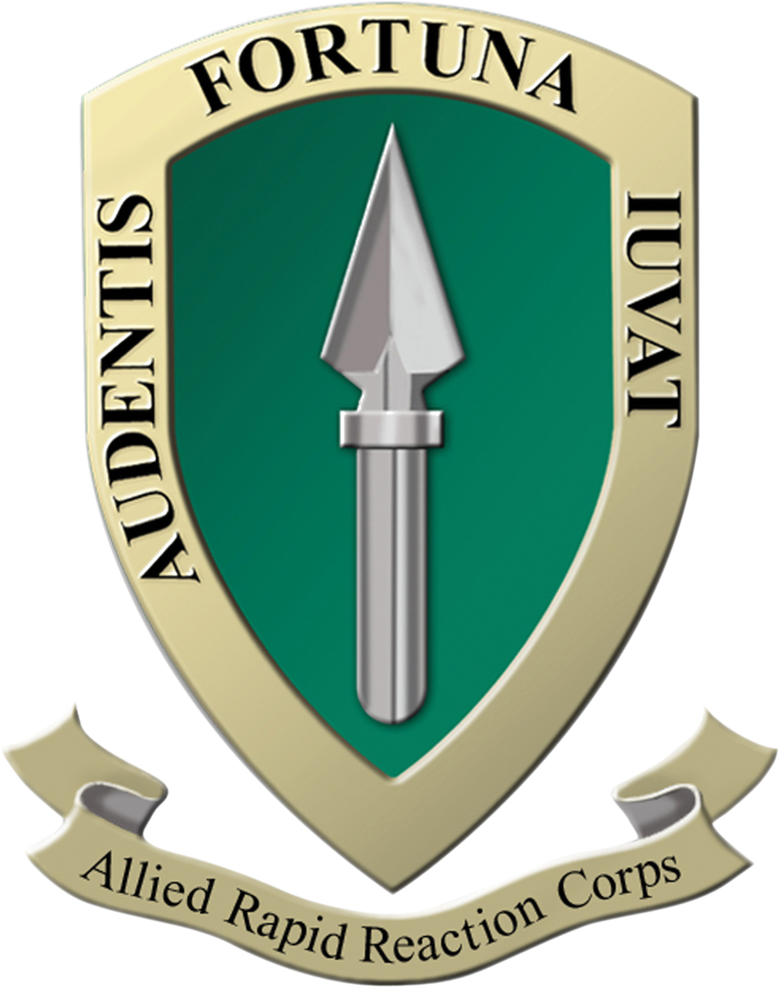
Headquarters Allied Rapid Reaction Corps
Imjin Barracks, Innsworth,
Gloucester, GL3 1HW

16th January 2013
HQ ARRC celebrates assumption of NRF 2013 role with military parade

Headquarters, Allied Rapid Reaction Corps (HQ ARRC) conducted a ceremony and parade earlier today to celebrate the NATO headquarters’ assumption of their role in NATO’s Response Force (NRF) for 2013.
The ceremony and parade occurred at the command’s headquarters on Imjin Barracks near Innsworth in Gloucestershire.
Although the ARRC officially began its year-long NRF rotation at the beginning of this month, the event offered a ceremonial opportunity for the commander of the 2012 NRF Land Component, Lt. Gen. Georgios Basiakoulis, NATO Rapid Deployable Corps – Greece (NRDC-Greece), to transfer his command’s (NRF) responsibility to HQ ARRC’s commander, Lt. Gen. Sir James Bucknall KCB CBE.
During the mid-morning ceremony, generals Basiakoulis and Bucknall reviewed the some 100 ARRC troops participating in the event, which included military personnel from the UK as well as many of the 15 other nations serving with the headquarters here in the UK.
Following the review of troops and subsequent transfer of the NRF flag from Lt. Gen. Basiakoulis to Lt. Gen. Sir James Bucknall, the UK Army’s Corps of Drums from the 1st Battalion, Coldstream Guards led the troops in a short march around the parade ground.
NATO announced in October 2012 that HQ ARRC was qualified for duty as part of the NRF in 2013.
The announcement came at the end of a week-long, comprehensive, and often grueling, evaluation conducted at RAF St. Mawgan, near Newquay, Cornwall, completed by a team of NATO military and civilian experts sent to assess the Innsworth-based high-readiness headquarters and determine their readiness to assume their designated role as the Land Component Command, or LCC, within the 2013 NRF.
HQ ARRC is now on stand-by for short-notice call-up and subsequent rapid deployment in support of any potential NRF missions that may develop during 2013.
NATO designates NRFs on a rotating basis, and they traditionally comprise land, air and sea components, volunteered and provided by NATO members.
An NRF is a coherent, high-readiness, joint, multinational force package of up to 25,000 troops that is technologically advanced, flexible, deployable, interoperable and sustainable. Its role is to act as a stand-alone military force available for rapid deployment as a collective-defense, crisis management or stabilization force, or to act as an initial entry force for a subsequent primary deployment.
As an NRF LCC, the ARRC will essentially be in command of all land combat troops on the ground during an NRF deployment.
“This ceremony formally acknowledges the enormous responsibility that the ARRC now takes on its shoulders,” stated ARRC spokesman Major Chris Hyde. “The ARRC is now the ‘tip of the spear’ for NATO, ready to deploy anytime, anywhere in 2013.”
HQ ARRC is a NATO Rapid Deployable Corps headquarters, founded in 1992 in Germany, and headquartered in Gloucestershire since August 2010.
Although HQ ARRC’s ‘framework nation’ is the United Kingdom, comprising approximately 60% of the overall staff, the ARRC is fully multinational in nature and organization, with 15 Partner Nations contributing the remaining complement of personnel (Belgium, Canada, the Czech Republic, France, Denmark, Germany, Greece, Italy, the Netherlands, Norway, Poland, Portugal, Spain, Turkey, and the United States).

For more information on the ARRC: www.arrc.nato.int or email: richard.hyde@us.army.mil, or phone: 07788 616008
For more photographs of this and other stories about the ARRC, please visit HQ ARRC on Flickr at: http://www.flickr.com/photos/54973278@N03/

