Major General Karl R. Horst
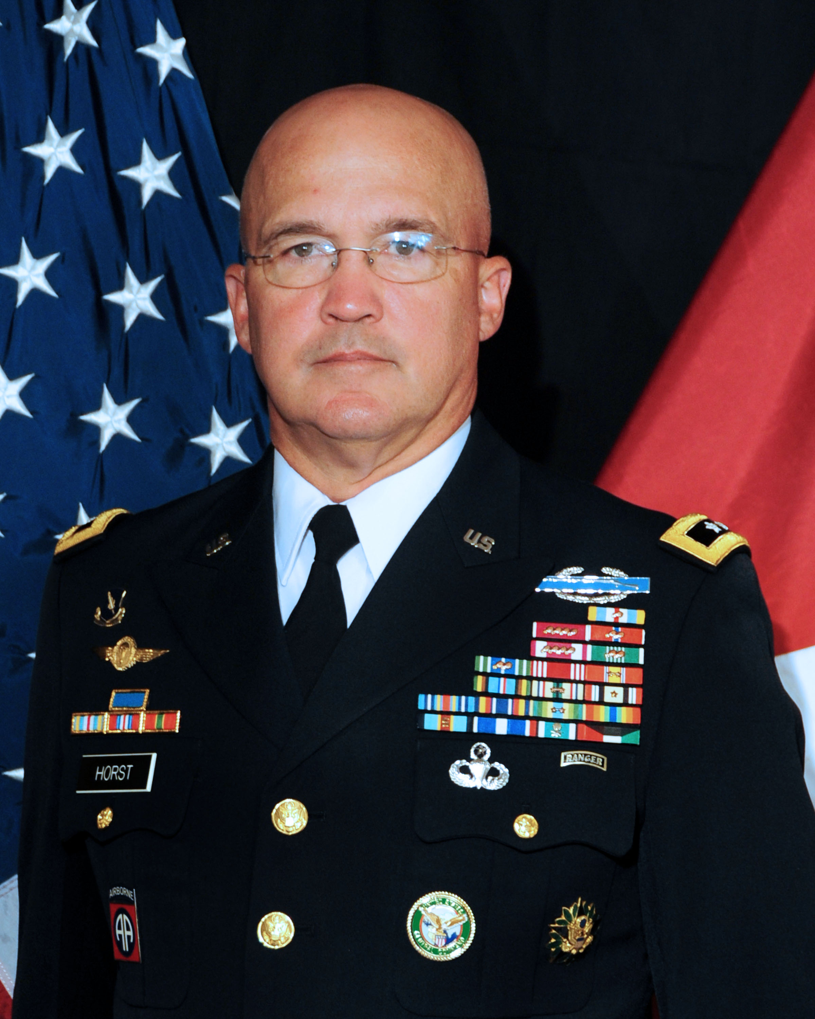
Maj. Gen. Karl R. Horst assumed duties as Chief of Staff U.S. Central Command on 18 July 2011
Maj. Gen. Horst reported to CENTCOM following a successful tour as the Commanding General of the U.S. Army Military District of Washington and Joint Force Headquarters National Capital Region on June 23, 2009.
Maj. Gen. Horst received his bachelor’s degree and commission in the Infantry from the United States Military Academy in 1978, after enlisting in the Army June 22, 1973 and attending the United States Military Academy Preparatory School at Ft. Belvoir, VA.
Maj. Gen. Horst started his career with the 3rd Infantry Division in the Federal Republic of Germany, where he served as a platoon leader. He went on to company command in the 9th Infantry Division, Fort Lewis, WA. Later Maj. Gen. Horst commanded both a battalion and a brigade in the 82d Airborne Division, Fort Bragg, NC. In July 2004, he became the 3rd Infantry Division’s Assistant Division Commander (Maneuver) and in September 2006, he assumed the duties as the Deputy Commanding General, XVIII Airborne Corps and Fort Bragg.
Maj. Gen. Horst's important staff assignments include an assignment on the Army staff as aide-de-camp to the Army Chief of Staff, and a joint and NATO assignment as special assistant to the Supreme Allied Commander, Europe. Maj. Gen. Horst served as the Chief of Staff, 82nd Airborne Division; then as the Chief of Staff, XVIII Airborne Corps and Fort Bragg. In his last joint assignment, he served as the Director for Operations, Plans, Logistics and Engineering (J3/J4), United States Joint Forces Command, Norfolk, VA.
Maj. Gen. Horst's military education includes the infantry officer basic and advanced courses, the Armed Forces Staff College, and the Army War College. His civilian study includes a master's degree in Public Administration from Shippensburg University of Pennsylvania.
Maj. Gen. Horst's awards include the Distinguished Service Medal, Defense Superior Service Medal (1 Oak Leaf Cluster), the Legion of Merit (4 Oak Leaf Clusters), and the Bronze Star Medal (2 Oak Leaf Clusters). He has earned the Expert Infantryman Badge, the Combat Infantryman Badge, the Combat Action Badge, the Master Parachutist Badge, and the Army Ranger Tab.
Maj. Gen. Horst is married to the former Nancy Pribyla of Tarzan, Texas and they have three children; Kaitlin, 25, is a Department of the Army civilian, an Army wife, and lives in Vicenza Italy with her husband, Mason; son Paul, 22, recently graduated from NC State University with a degree in business and is entering the work force; and daughter Megan, 20, is a junior at NC State University, studying elementary education.

